**Hackathon Project Phases Template for** the Flavour Fusion **App** project.

# Hackathon Project Phases Template

**Project Title:**

**Flavour Fusion App**

**Team Name:**

Ruchi Sangam

**Team Members:**

* Surigi Prasanna Goud
* Veligandla Lakshmi Praveena
* Pratiksha Shinde
* Ramagiri Rushi Kumar
* Nampally Manish Kumar

## Phase-1: Brainstorming & Ideation

**Objective:**

To leverage AI technology in flavour fusion recipe blogging by generating innovative, personalized, and culturally diverse recipes that cater to user preferences, promote culinary creativity, and enhance the overall cooking experience.

**Key Points:**

1. **Problem Statement:**

* 1. With the growing demand for diverse and personalized culinary experiences, there is a need for innovative platforms that generate unique flavour fusion recipes. However, manually curating fusion recipes that balance taste, cultural authenticity, and dietary preferences is time-consuming and complex. The challenge lies in developing an AI-driven recipe blogging platform that can intelligently generate, customize, and recommend fusion recipes while maintaining flavour harmony, nutritional value, and user engagement.

1. **Proposed Solution:**

* 1. To address the challenge of creating personalized and innovative flavour fusion recipes, the proposed solution is to develop an AI-driven recipe blogging platform that leverages machine learning and data analytics to generate, customize, and recommend fusion recipes.

1. **Target Users:**

* 1. Individuals seeking personalized and innovative recipes for daily cooking

○ Influencers and vloggers

generating food-related content

for social media

○ Researchers studying AI

applications in food innovation and

sustainability.

1. **Expected Outcome:**

* 1. A functional AI-powered FlavourFusion app that provides insights based on real-time data and user queries.

## Phase-2: Requirement Analysis

**Objective:**

Define the technical and functional requirements for the FlavourFusion.

**Key Points:**

1. **Technical Requirements:**

* 1. Programming Language: **Python**

○ Backend: **Python**

○ Frontend: html , CSS

○ Database: **Not required initially (API-based queries)**

1. **Functional Requirements:**

* 1. Secure login with two-factor authentication.

○ Allow bloggers to create, edit and delete blogs posts.

.

1. **Constraints & Challenges:**

* 1. Real-time AI processing speed for large datasets or media content.

○ Ensuring AI-generated recipes

are unique, high-quality and not

plagiarized.

○ Providing a **smooth UI experience**

with Streamlit.

## Phase-3: Project Design

**Objective:**

Develop the architecture and user flow of the application.

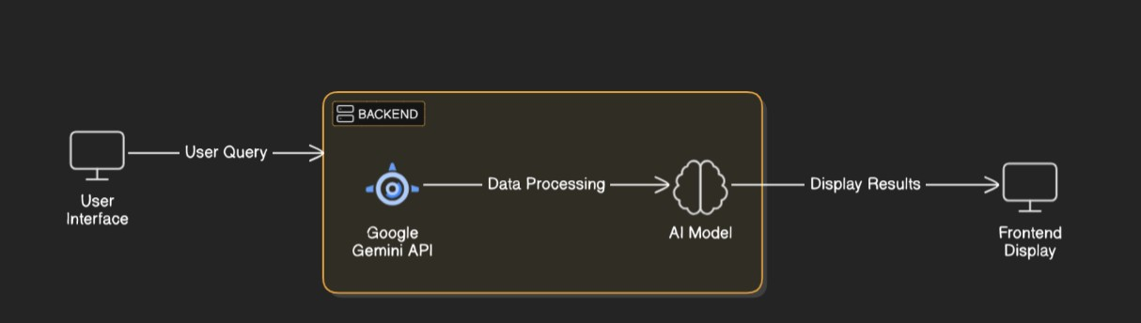

**Key Points:**

1. **System Architecture:**

* 1. User enters vehicle-related query via UI.

○ AI model fetches and processes the data.

○ The frontend displays **vehicle details, reviews, and comparisons**.

1. **User Flow:**

* 1. Step 1: User enters a query (e.g., "Italian Dish").

○ Step 2: The backend **calls the python** to retrieve vehicle data.

○ Step 3: The app processes the data and **displays results** in an easy-to-read format.

1. **UI/UX Considerations:**

* 1. **Minimalist, user-friendly interface** for seamless navigation.

○ **Filters for price, mileage, and features**.

○ **Dark & light mode** for better user experience.

## Phase-4: Project Planning (Agile Methodologies)

**Objective:**

Break down development tasks for efficient completion.

|  |  |  |  |  |  |  |  |
| --- | --- | --- | --- | --- | --- | --- | --- |
| **Sprint** | **Task** | **Priority** | **Duration** | **Deadline** | **Assigned To** | **Dependencies** | **Expected**  **Outcome** |
| Sprint 1 | Environment Setup  & API Integration | 🔴 High | 6 hours  (Day 1) | End of Day  1 | Prasanna | Google API Key,  Python, Streamlit setup | API connection established & working |
| Sprint 1 | Frontend UI Development | 🟡  Medium | 2 hours  (Day 1) | End of Day  1 | Prasanna and Manish | API response format finalized | Basic UI with input fields |
| Sprint 2 | Recipe search | 🔴 High | 3 hours  (Day 2) | Mid-Day 2 | Rishi and Praveena | API response, UI elements ready | Search functionality with filters |
| Sprint 2 | Error Handling &  Debugging | 🔴 High | 1.5 hours  (Day 2) | Mid-Day 2 | Prasanna and Manish | API logs, UI inputs | Improved API stability |
| Sprint 3 | Testing & UI  Enhancements | 🟡  Medium | 1.5 hours  (Day 2) | Mid-Day 2 | Prasanna, Rishi, Manish, Pratiksha, Praveena | API response, UI layout completed | Responsive UI, better user experience |
| Sprint 3 | Final Presentation  & Deployment | 🟢 Low | 1 hour  (Day 2) | End of Day  2 | Entire Team | Working prototype | Demo-ready project |

**Sprint Planning with Priorities**

**Sprint 1 – Setup & Integration (Day 1)**

**(**🔴 **High Priority)** Set up the **environment** & install dependencies.

**(**🔴 **High Priority)** Integrate **Google Gemini API**.

**(**🟡 **Medium Priority)** Build a **basic UI with input fields**.

**Sprint 2 – Core Features & Debugging (Day 2)**

**(**🔴 **High Priority)** Implement **search & comparison functionalities**. **(**🔴 **High Priority)** Debug API issues & handle **errors in queries**. **Sprint 3 – Testing, Enhancements & Submission (Day 2)**

**(**🟡 **Medium Priority)** Test API responses, refine UI, & fix UI bugs. **(**🟢 **Low Priority)** Final **demo preparation & deployment**.

## Phase-5: Project Development

**Objective:**

Implement core features of the Flavour Fusion App.

**Key Points:**

1. **Technology Stack Used:**

* 1. **Frontend:** html, CSS

○ **Backend:** python

○ **Programming Language:** Python

1. **Development Process:**

* 1. Implement **API key authentication** and **Gemini API integration**.

○ Develop **recipes**.

○ Optimize **search**

**queries for performance**

**and relevance**.

1. **Challenges & Fixes:**

* 1. **Challenge:** Delayed API response times.

**Fix:** Implement **caching** to store frequently queried results.

○ **Challenge:** Limited API calls per minute.

**Fix:** Optimize queries to fetch **only necessary data**.

## Phase-6: Functional & Performance Testing

**Objective:**

Ensure that the FlavourFusion App works as expected.

|  |  |  |  |  |  |
| --- | --- | --- | --- | --- | --- |
| **Test Case ID** | **Category** | **Test Scenario** | **Expected Outcome** | **Status** | **Tester** |
| TC-001 | Functional  Testing | Query "continental food " | Displays ingredients, steps-by-step instructions, nutrients and tips. | ✅ Passed | Prasanna 1 |
| TC-002 | Performance  Testing | API response time under  500ms | API should return results quickly. | ✅ Passed | Prasanna |
| TC-003 | Bug Fixes & Improvements | Fixed incorrect API responses. | Data accuracy should be improved. | ✅ Fixed | Prasanna |
| TC-004 | Final Validation | Ensure UI is responsive across devices. | UI should work on mobile & desktop. | ❌ Failed - UI broken on mobile | Test |
| TC-005 | Deployment  Testing | Host the app using  Streamlit Sharing | App should be accessible online. | 🚀 Deployed | DevOps |

## Final Submission

1. **Project Report Based on the templates**
2. **Demo Video (3-5 Minutes)**
3. **GitHub/Code Repository Link**
4. **Presentation**